**Experiment No.: 3**

**Aim**

Familirization of linux commands

**CO2**

Perform system administration tasks

**Procedure**

1.pwd-To print working directory

$pwd

**Output Screenshot**

pwd1

2.ls-Used to list the files and contents

$ls

**Output Screenshot**

ls 1

(a).ls-R-Detailed view of sub directory

$ls-R

**Output Screenshot**

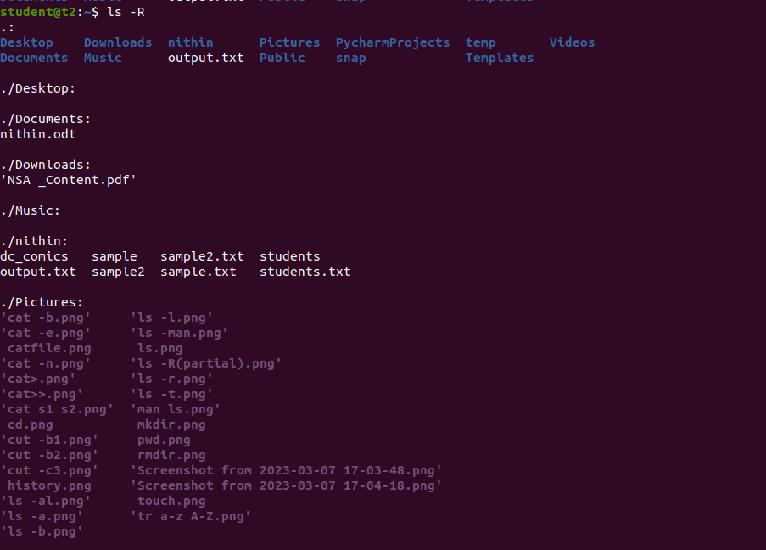

(b).ls-l-long listing of contents

$ls

**Output Screenshot**

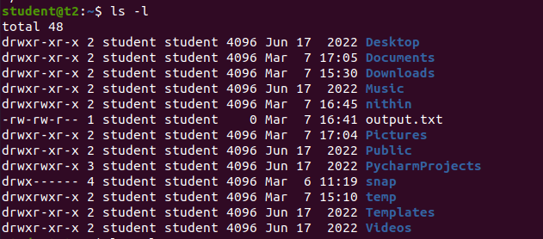

(c).ls-a-used to view hidden files

$ls-a

**Output Screenshot**



(d).ls-al-Detailed information can view along with hidden files.

$ls-al

**Output Screenshot**

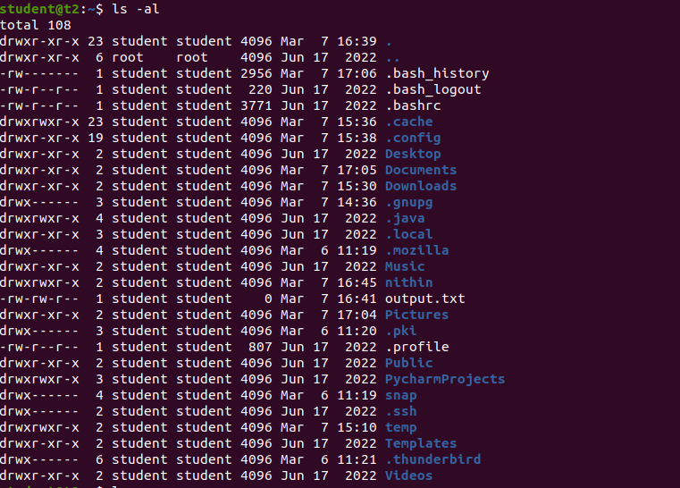

(e).ls-t-To list the files sorted in order of last modified.

$ls-t

**Output Screenshot**

ls t 1

(f).ls -r: reverse the actual sorting order.

$ls -r

**Output Screenshot**

ls small r 1

3.mkdir-To make a new directory

**Output Screenshot**

create file

4.cd-To navigate through directory we used cd.

$cd anjali

**Output Screenshot**

navgate

5.cd.. or cd-- -To move one directory up

$cd-- $cd..

**Output Screenshot**

move up cd

6.history-To view the history and commands which we have been executed for a long time.

$history

**Output Screenshot**

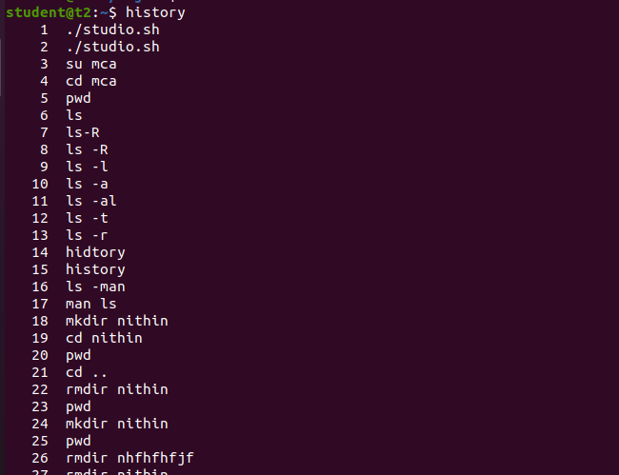

7.man-We can learn &understand with different commands write from the shell using man commands.

$manls

**Output Screenshot**

man 1

8.cat-To create a new file.

$cat > file name

**Output Screenshot**

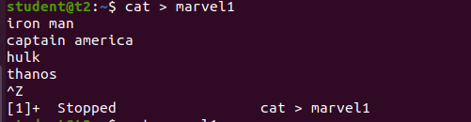

(a).cat filename-To display contents

$cat filename

**Output Screenshot**



(b).cat>>-To append content to the file

$cat >> filename

**Output Screenshot**

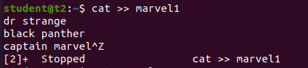

(c).cat-n-To display the the line number

$cat-n filename

**Output Screenshot**

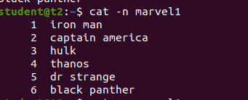

(d).cat-b-Removing the empty line numbering

$cat-b

**Output Screenshot**

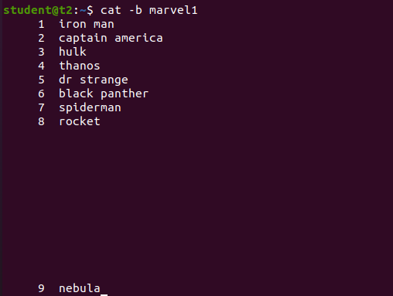

**Result**

The program was executed and the result was successfully obtained. Thus CO2 was obtained.

**Experiment No.: 4**

**Aim**

Familiarization with Linux command.

**CO2**

Perform system administration tasks.

**Procedure**

1. i. cut -c[filename]: To cut by character,for cutting out sections from each line of file and writting the result to standard output.

$ cut -c 1,3,5 file1

**Output Screenshot**

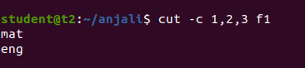

ii. cut -b :To cut by byte position

$ cut -b 2 file1

**Output Screenshot**

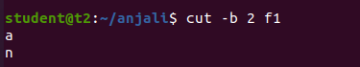

iii. cut -d : To cut by delimiter

$ cut -d - -f1 file1

**Output Screenshot**

cut -d column

iv.. cut - complement : Cut by complement pattern

$ cut - - complement -c 1 file1

**Output Screenshot**

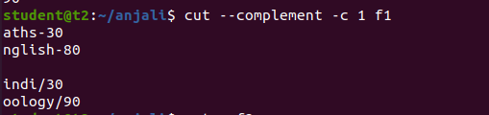

1. paste : Paste command is used to join files consist of lines from each file horizontally outputing lines.

i. $ paste file2 file1

**Output Screenshot**

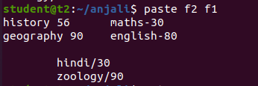

ii.$ paste -d ‘%’ n1 n2 >n3

$ cat n3

**Output Screenshot**

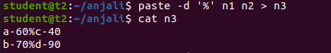

1. cp : copy the content.
2. $ cp filename newfilename: copy to new file

$cp test3 test4

**Output Screenshot**



1. $cp file1 file2: Overwrite the existing file.

$cp test1 test3

**Output Screenshot**

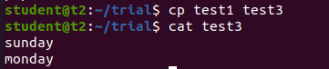

**Result**

The program was executed and the result was successfully obtained. Thus CO2 was obtained.